Supplementary information for the article entitled: “Self-reported sleep quality and longitudinal amyloid burden in cognitively unimpaired adults from the AMYPAD study”

SUPPLEMENTARY TABLES:

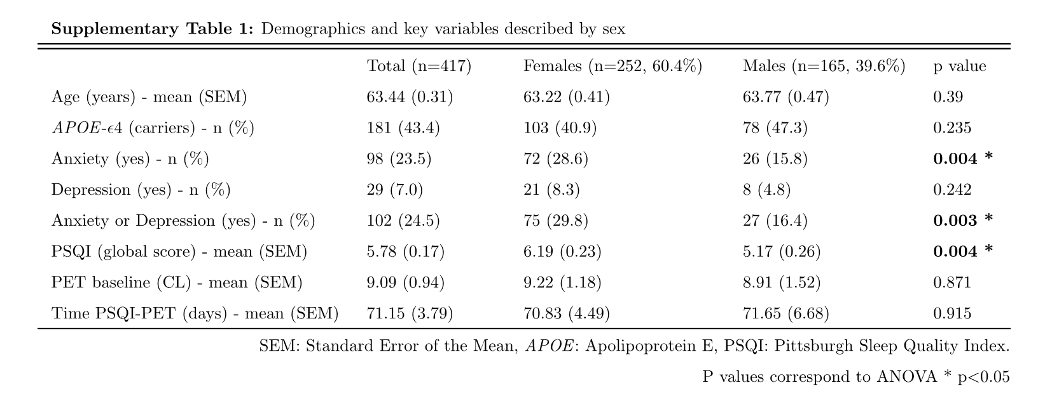

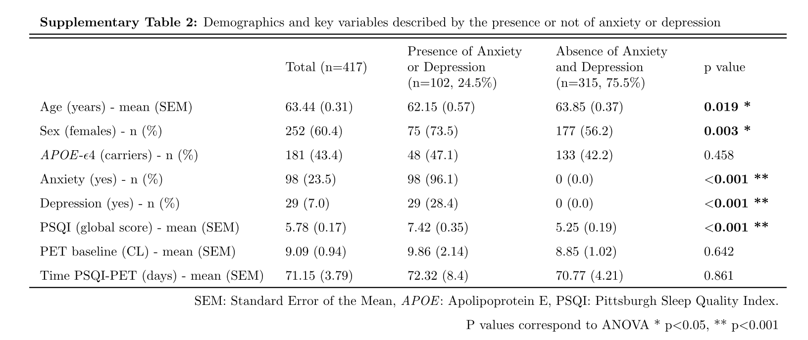
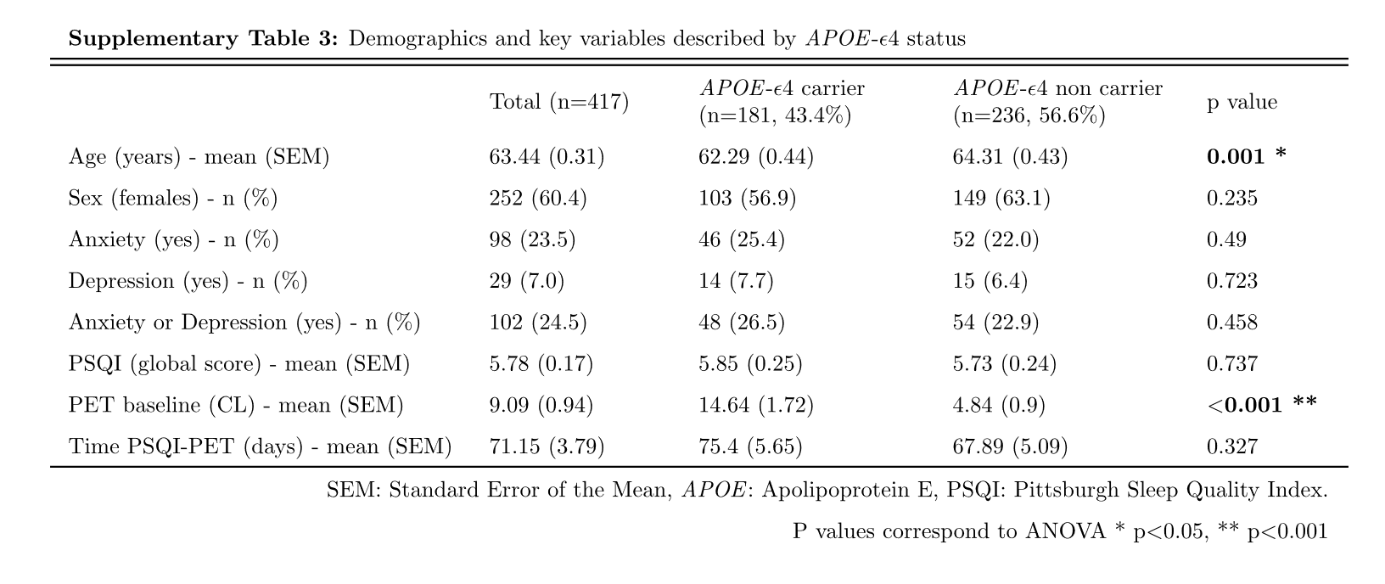
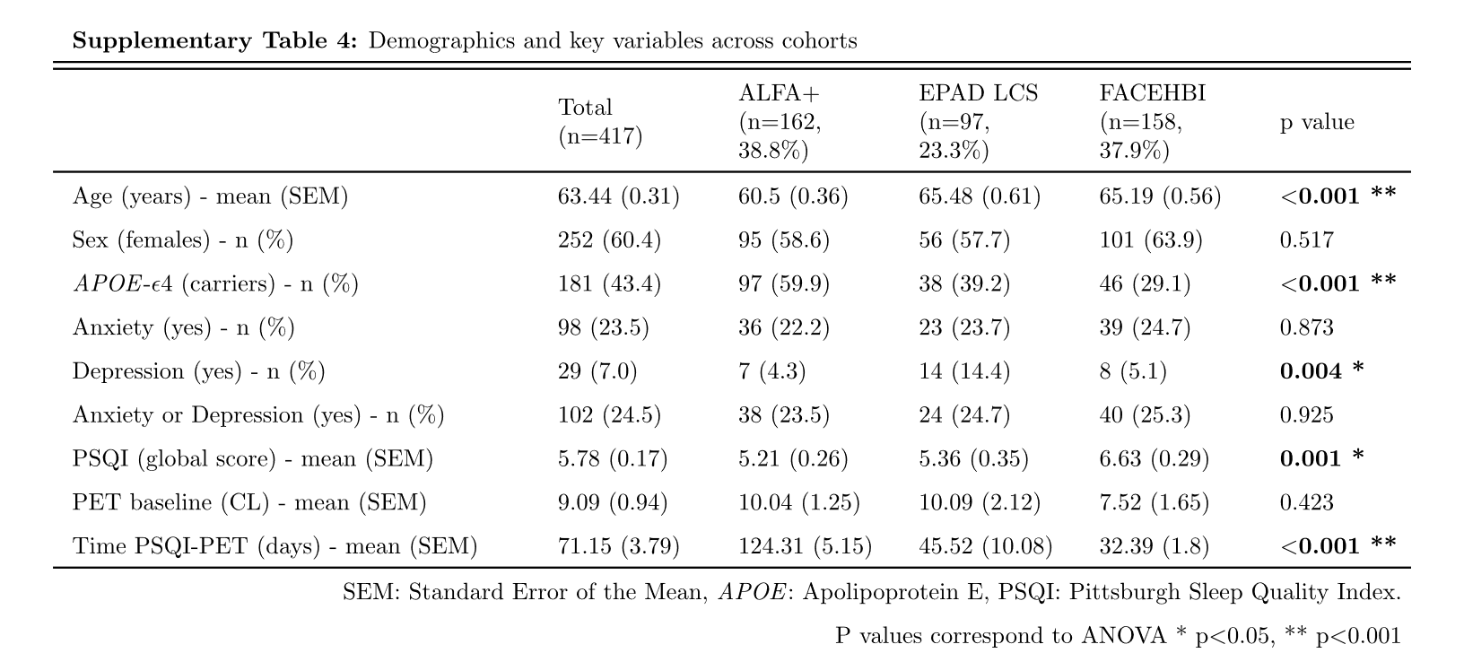

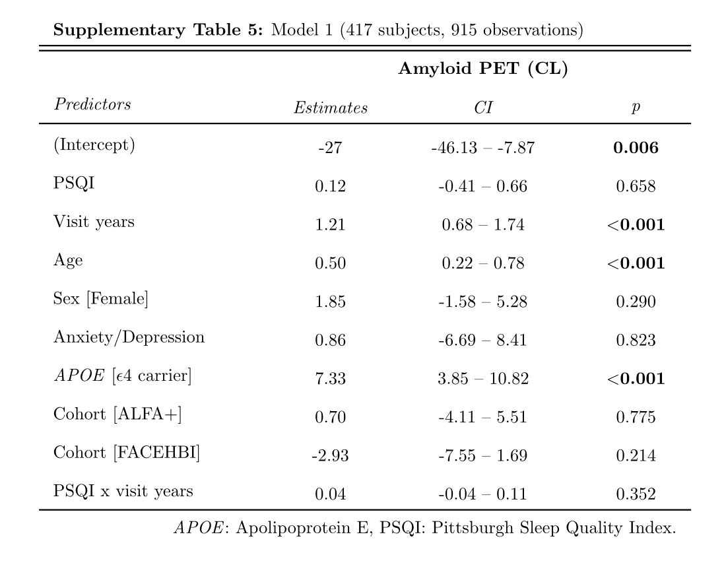
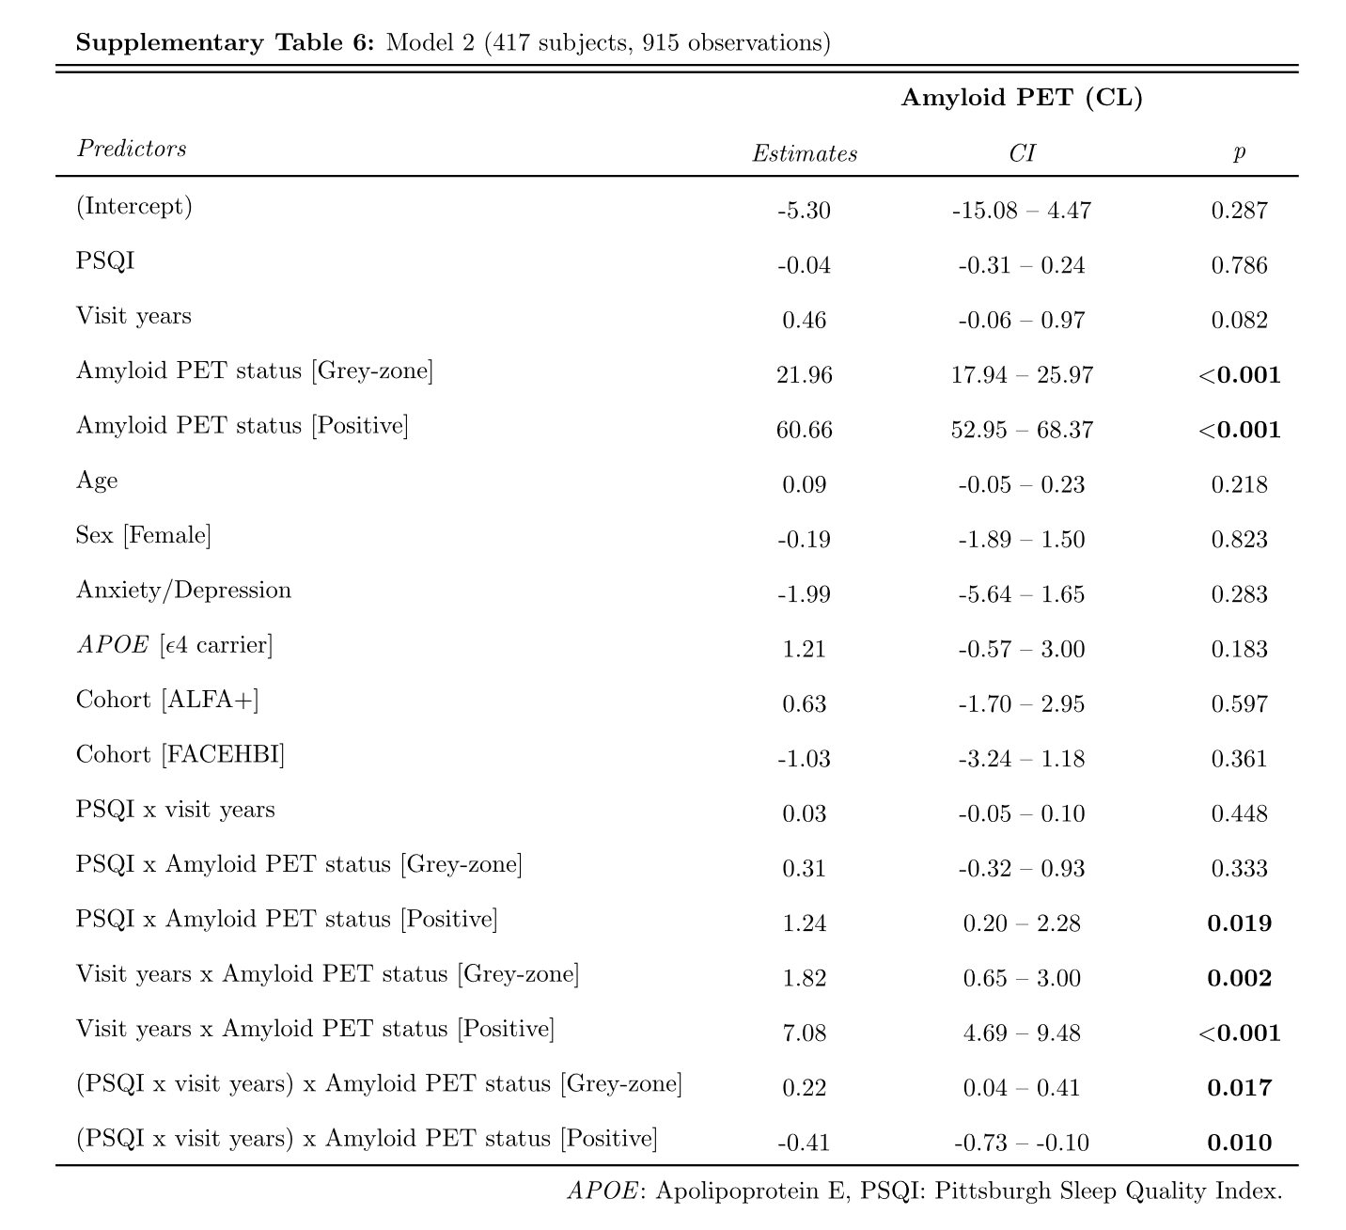

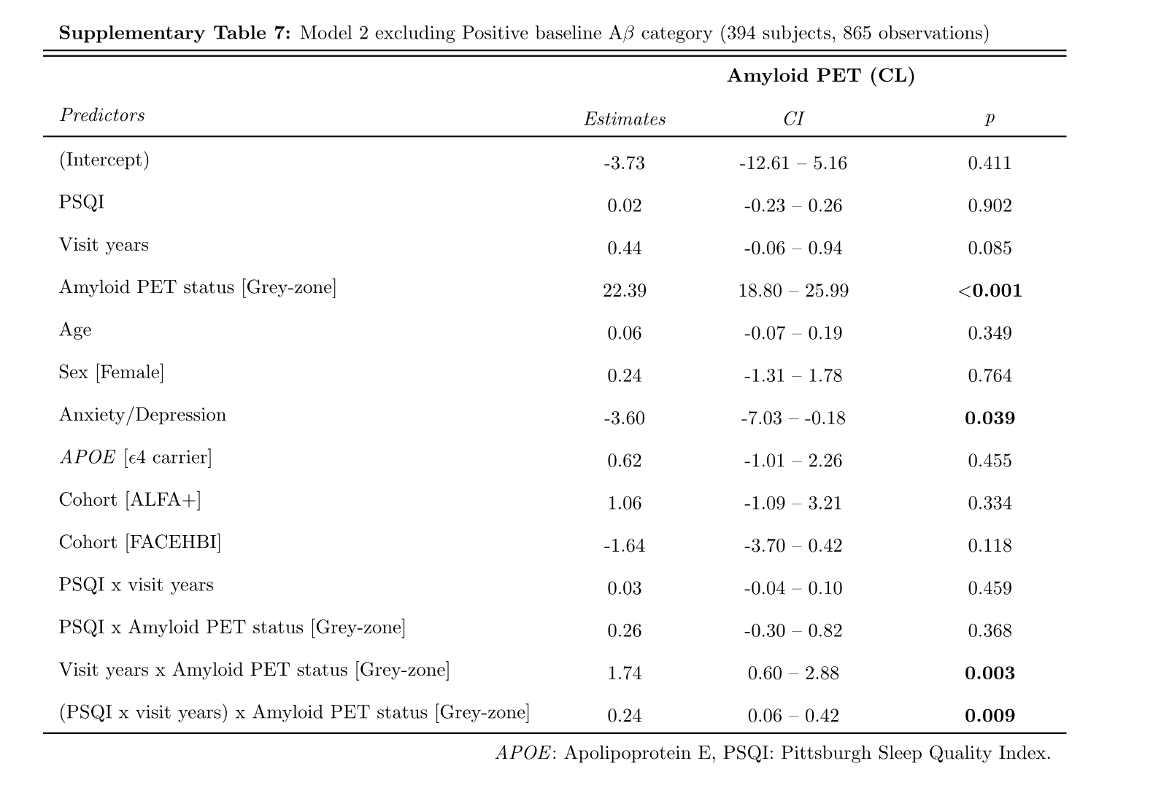
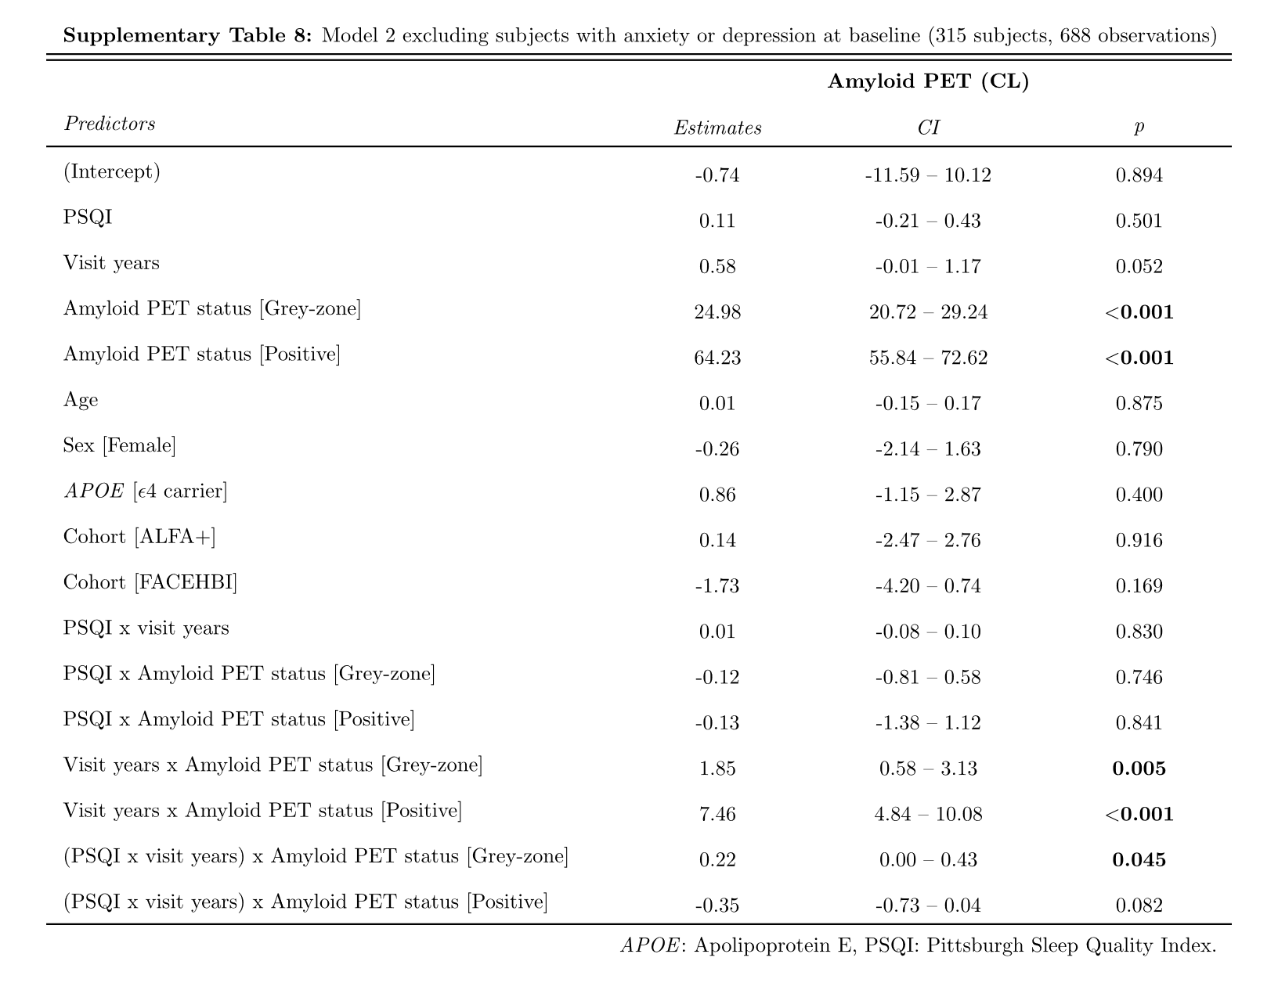

SUPPLEMENTARY FIGURES:

Supplementary Figure 1: QQ plots (top) and residuals distribution (bottom) for Model 1.
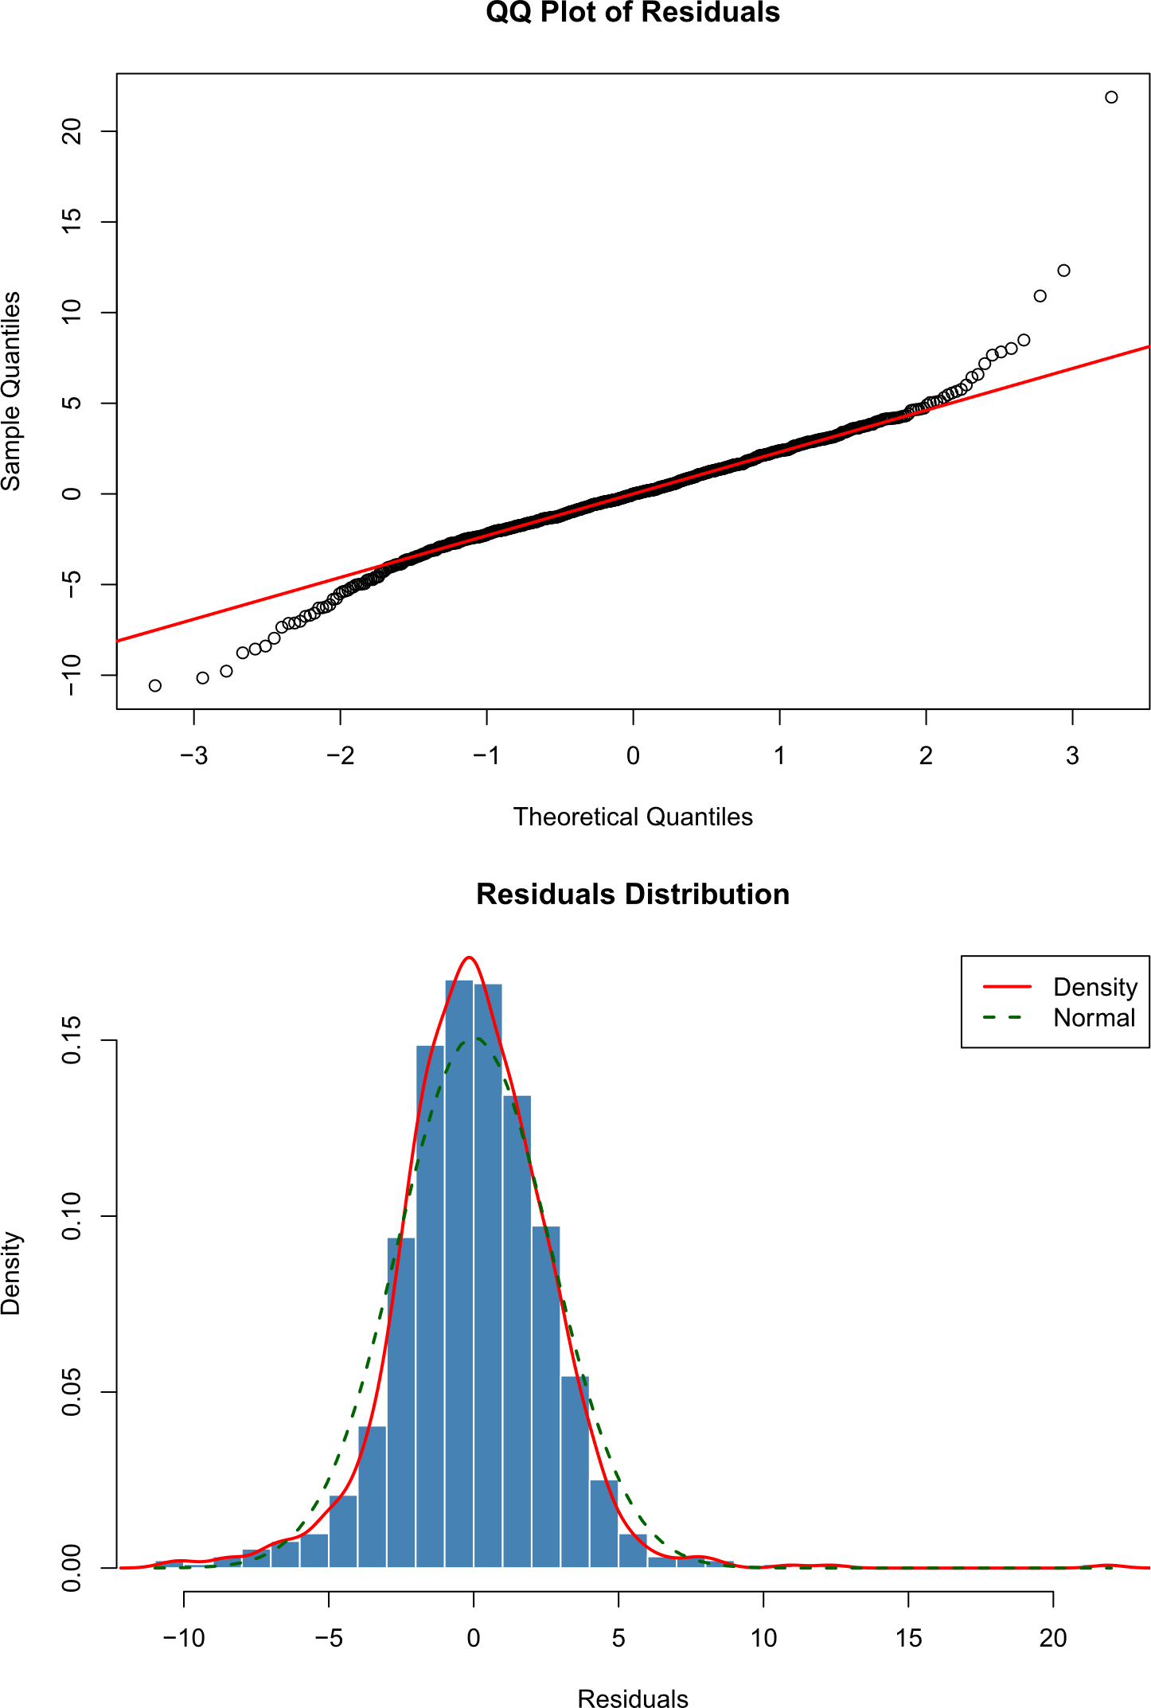
Supplementary Figure 2: QQ plots (top) and residuals distribution (bottom) for Model 2:
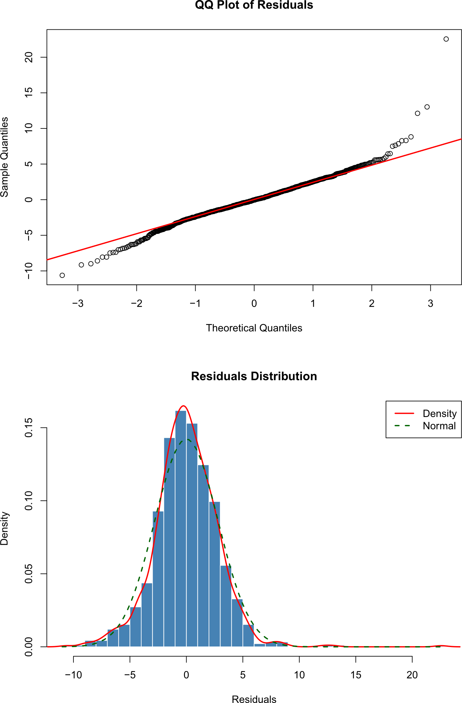

Supplementary Figure 3: Histograms of PSQI values in each category of baseline amyloid burden. Vertical lines correspond the representative values of PSQI scores for each tertile (green for good sleep quality, orange for medium sleep quality and red for bad sleep quality).
